Subject: Welcome to the International Health & Wellness Expo 2025

Dear Dr. Vijay Sharma,  Greetings from Namo Gange Trust (NGT)!  Congratulations on successfully registering as an Exhibitor for the 8th Edition of the International Health & Wellness Expo, the 2nd Edition of Agritech Innovate India, and the 15th Edition of the Arogya Sangosthi Seminar. We are thrilled to have you join us at this prestigious event, bringing together industry leaders, innovators, and experts from across various sectors.  However, we noticed that your payment process is still incomplete. To ensure your participation and secure your stall, we kindly request that you complete the payment at your earliest convenience. Your stall will only be confirmed once we receive the payment. | 

Please review the registration details carefully. If there are any discrepancies or updates required, kindly let us know so we can assist you promptly.
Your Registration Details:
- Company Name: Pharma wise Pvt Ltd. Facia Name: Pharma wise Pvt Ltd
- Address: 1254/A, ABC Tower, Rajouri Garden, Delhi, Bharat
- First Contact Person: Mohit Tyagi |Director | 984563214 | mohit@pharmawise.com
- Second Contact Person: Mohit Tyagi |Director | 984563214 | mohit@pharmawise.com
- Exhibition Stall Details: Stall Size: 9 Sq m. (3mt x 3mt) Shall Scheme & Stall No.: 26
- Contact Number: 9810247516
- Email: mohit@yahoo.com Website: www.abac.com
- GST/Pan No.: 964582156addw | 5464131646
- Industry/Sector: Ayush
- Nature of Business: Manufacturer
- Industry Information: Hospitals & Clinics

Event Details:
Event Date:11th July - 13th July 2025
Venue: Hall No. 12, Pragati Maidan, New Delhi, Bharat Direction
Payment Details:
Stall Rate: 11700/- Per Sqm Total Cost: 96500/- GST 18% : 7500/-
Total Cost: 103500/-
Payment Process: To secure your stall, kindly complete the payment process. Your stall will only be confirmed once the payment is received. Please use the following link to make your payment:
Please click on the link below to complete your payment:

For Payment Click Here!

Do not miss this incredible opportunity to connect, network, and grow. We look forward to your participation!

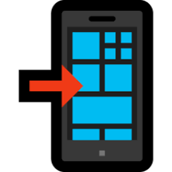Follow Us on social media for International Health & Wellness Expo Updates:
Facebook | Instagram | Website | LinkedIn

How to Reach the Venue
- By Metro: If you are traveling by metro, please get down at Pragati Maidan Metro Station. From there, our shuttle service will be available to take you directly to the event venue at Hall No. 12
- By Public Transport: If you are arriving by bus, auto, or taxi, please enter through Pragati Maidan Gate No. 10. From there, our shuttle service will take you to Hall No. 12.
- By Car: If you are coming by your own vehicle, you can park your car at Basement 2, Pragati Maidan Parking. After parking, step outside, and our shuttle service will pick you up and take you to Hall No. 12.

If you need any further information or any help, feel free to contact our team members, who will be happy to assist you:
Renu Yadav: 7042818092 | Reetika Singh: 9773992519 | Vipin Sharma: 9310608427

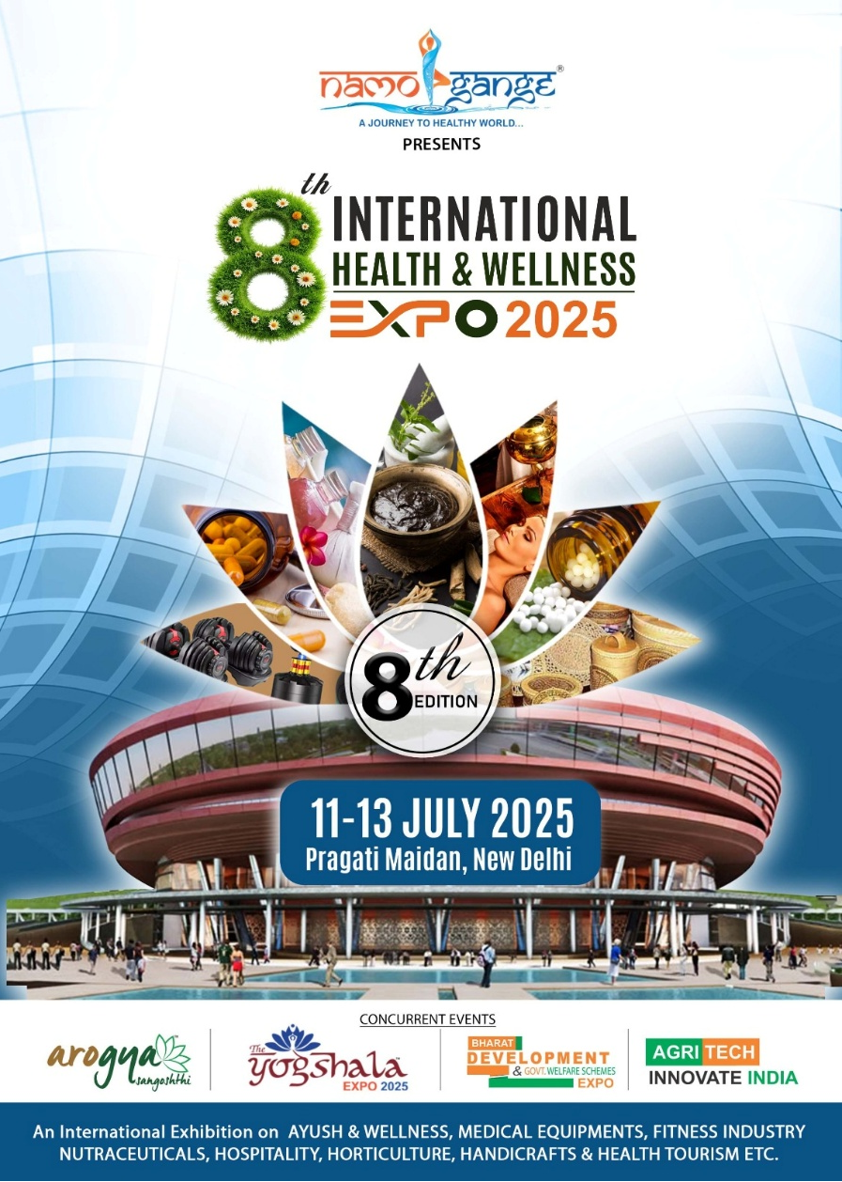
We look forward to welcoming you to the International Health & Wellness Expo, Agritech Innovate India, and the Arogya Sangosthi Seminar. See you there! 

Warm regards,
Vijay Sharma
Chairman - Namo Gange Trust

Subject: Follow-up on Payment Process for 8th Edition International Health & Wellness Expo

Dear Team,
Greetings from Namo Gange Trust (NGT)!
This is to update you regarding the payment status of Pharmawise Pvt. Ltd., who has registered for the 8th Edition International Health & Wellness Expo but has not yet completed the payment process.

Exhibitor Details :
Company Details | : | Pharmawise Pvt Ltd | MSME Scheme  Address: 1254/A, ABC Tower, Rajouri Garden, Delhi, Bharat
Stall Details | : | 9 Sq m. (3mt x 3mt) Shall Scheme & Stall No.: 26
Contact Details: | : | Mohit Tyagi |Director | 984563214 | mohit@pharmawise.com  Mohit Tyagi |Director | 984563214 | mohit@pharmawise.com
Email & Website |  | Email: mohit@yahoo.com Website: www.abac.com

Next Steps :
- A follow-up email has been sent to the exhibitor with the payment link and instructions.
- The exhibitor has been informed that the invoice and payment receipt will be shared via email & WhatsApp after successful payment.
- If the payment is not completed within the given timeframe, a further reminder may be needed.

Payment Process:
Please click on the link below to complete Exhibitor payment:

For Payment Click Here!

Warm regards,
Vijay Sharma
Chairman - Namo Gange Trust

